Project Specifications:
Functional Requirements:-
The system must support the following features based on the current implementation:
- User Authentication
  - Users can register with a name, email, and password.
  - Users can log in with email and password.
  - Validation for email format (must include '@').
  - Display success/error messages via popups (e.g., "Login successful (dummy for now!)").
  - Redirect or block access to protected pages (e.g., dashboard) if not authenticated.
- Navigation and Pages
  - Global navigation bar with links: Home, Dashboard, Login, Register.
  - Home Page: Display welcome message and project description.
  - Dashboard: Accessible only to logged-in users; currently shows access denial message if unauthenticated.
- UI Elements
  - Forms with input fields, buttons (e.g., blue "Login", green "Register").
  - Emojis for visual feedback (e.g., for welcome, for not logged in).
  - Links between pages (e.g., "Register here" on login page).
- Future Functional Extensions (Planned)
  - Integrate AI for traffic prediction using models like LSTM.
  - Fleet data simulation and visualization on dashboard (e.g., maps with markers).
  - Route optimization via graph algorithms.
Non-Functional Requirements:-
- Performance: Pages load in <2 seconds on local setup. Handle up to 10 concurrent users in prototype.
- Security: (Current: Basic client-side validation; Planned: Server-side auth with JWT, hashed passwords, HTTPS). No real data storage yet to avoid vulnerabilities.
- Usability: Intuitive UI with clear error messages, responsive design (mobile-friendly planned).
- Scalability: Designed for easy backend integration; use modular components in React.
- Accessibility: Basic (e.g., alt text for emojis planned); comply with WCAG 2.1 Level A.
- Reliability: Error handling for invalid inputs; dummy successes ensure flow continuity.
- Compatibility: Works on modern browsers (Chrome, Edge, as shown in screenshots).
System Architecture:-
- High-Level Design:Client-server model (frontend React app communicating with future backend API).
  - Frontend: React components for pages (e.g., Login.js, Register.js, Dashboard.js). State management via React hooks (e.g., useState for form data).
  - Backend: (Placeholder) Future: RESTful API for /login, /register, /fleet-data. Database: MongoDB for users and fleet data.
  - Data Flow: User interacts with UI → Form submission → API call (dummy now) → Response popup → Redirect if success.
Components Diagram (Text-Based):
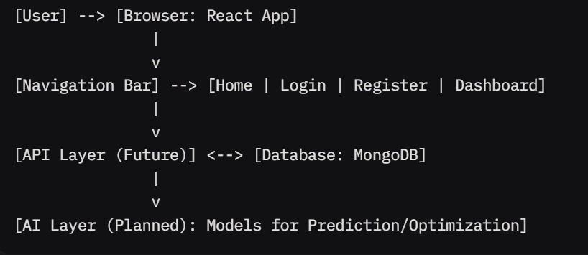
User Roles and Permissions:-
- Guest (Unauthenticated): Access Home, Login, Register. Blocked from Dashboard.
- Registered User: Access all pages, including Dashboard. (Current: No role differentiation; all users equal).
- Admin (Planned): Manage fleet data, view analytics.
APIs and Endpoints:-
- Current (Dummy): Handled client-side.
- Planned REST Endpoints:
  - POST /register: Create user.
  - POST /login: Authenticate and return token.
  - GET /dashboard: Fetch user-specific data (auth required).
  - GET /fleet-data: Retrieve simulated fleet info.

Test Cases:
Unit Tests:-
Focus on individual components/functions. Assume Jest for React testing.
- Email Validation Function
  - Test Case 1: Valid email ("anuragtiwari3005@gmail.com") → Expect no error.
  - Test Case 2: Invalid email ("anuragtiwari3005ail.com") → Expect error: "missing '@'".
  - Test Case 3: Empty email → Expect error: "Email required".
- Form Submission (Login)
  - Test Case 1: Valid credentials (dummy) → Expect success popup.
  - Test Case 2: Invalid password → Expect error message (future backend).
- Navigation Link Rendering
  - Test Case 1: Render navbar → Expect 4 links present.
Integration Tests:-
Test interactions between components (e.g., using React Testing Library).
- Login Flow
  - Test Case 1: Enter valid email/password → Submit → See success popup → Redirect to Dashboard.
  - Test Case 2: Enter invalid email → Submit → See validation error, no submission.
- Registration to Login
  - Test Case 1: Register new user → Success popup → Click "Login here" → Navigate to login page.
- Dashboard Access
  - Test Case 1: Unauthenticated access → See "You are not logged in" message.
  - Test Case 2: After login → See dashboard content (placeholder).
UI/Functional Tests:-
Manual or automated (e.g., Cypress for end-to-end).
- Page Loading
  - Test Case 1: Load Home → Verify welcome text and emoji.
  - Test Case 2: Load Login → Verify form fields pre-filled or empty.
- Popup Interactions
  - Test Case 1: Successful login → Click "OK" on popup → Dismiss popup.
- Cross-Page Navigation
  - Test Case 1: From Login → Click "Register here" → Load Register page.
Edge Cases and Error Handling:
- Invalid Inputs
  - Test Case 1: Password <6 chars on register → Expect client-side error (add if not present).
  - Test Case 2: Duplicate email on register → Expect backend error (future).
- Network/Backend Failures
  - Test Case 1: Simulate API failure → Show generic error popup.
- Browser Compatibility
  - Test Case 1: Test on Chrome/Edge → No layout breaks.
  - Test Case 2: Resize window → Responsive (if implemented).
Test Coverage Goal: 80% for current features. Use tools like Jest for automation.
Assumptions and Dependencies:
- Assumptions: Users have modern browsers; no real auth backend yet (dummy only).
- Dependencies: React 18+, Node.js for build; MongoDB for future data. No external APIs integrated yet.
Future Enhancements:
- Full backend with auth and database.
- AI integration (e.g., LSTM for traffic).
- Map visualization on dashboard.
- Mobile app companion
Appendix:-
- Screenshots:-

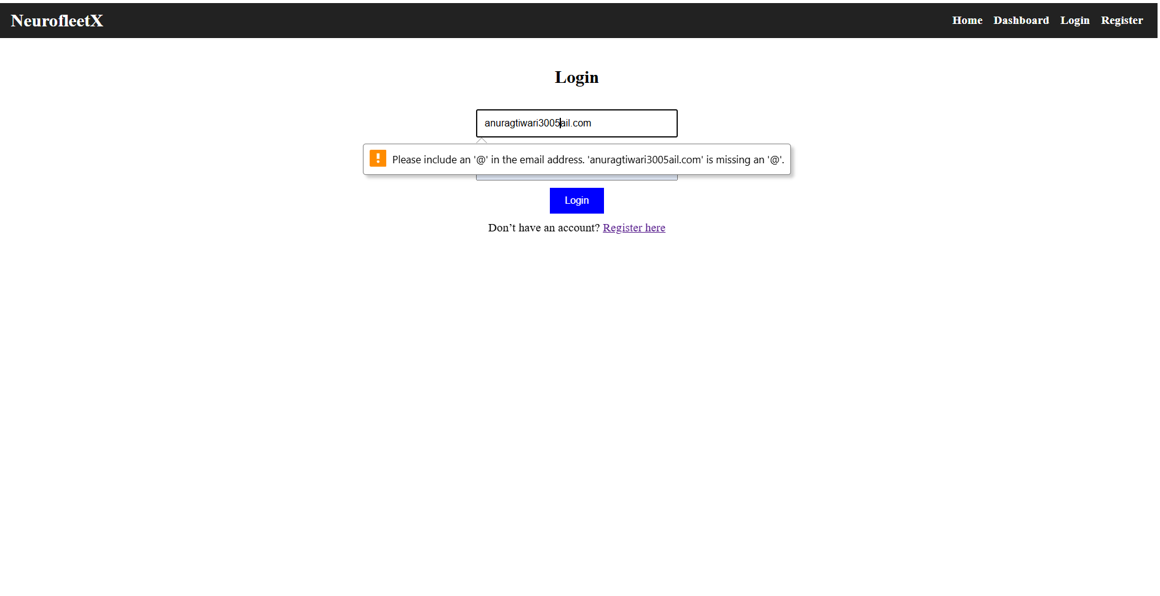
- Code Snippets (Example for Login Component):-
// Login.js (pseudocode)
import React, { useState } from 'react';

const Login = () => {
const [email, setEmail] = useState('');
const [password, setPassword] = useState('');
const [error, setError] = useState('');

const handleSubmit = (e) => {
e.preventDefault();
if (!email.includes('@')) {
setError("Missing '@' in email");
} else {
// Dummy success
alert("Login successful (dummy for now!)");
}
};

return (
<form onSubmit={handleSubmit}>
<input value={email} onChange={(e) => setEmail(e.target.value)} />
<input type="password" value={password} onChange={(e) => setPassword(e.target.value)} />
{error && <p>{error}</p>}
<button type="submit">Login</button>
</form>
);
};

